SIMPLELEARN Full Stack Developer - MERN Stack Masters Program
Course – 2 Build a strong MERN Foundation
Assessment – Screenshots for Project Implementation
Student Name : Vedaang Sharma

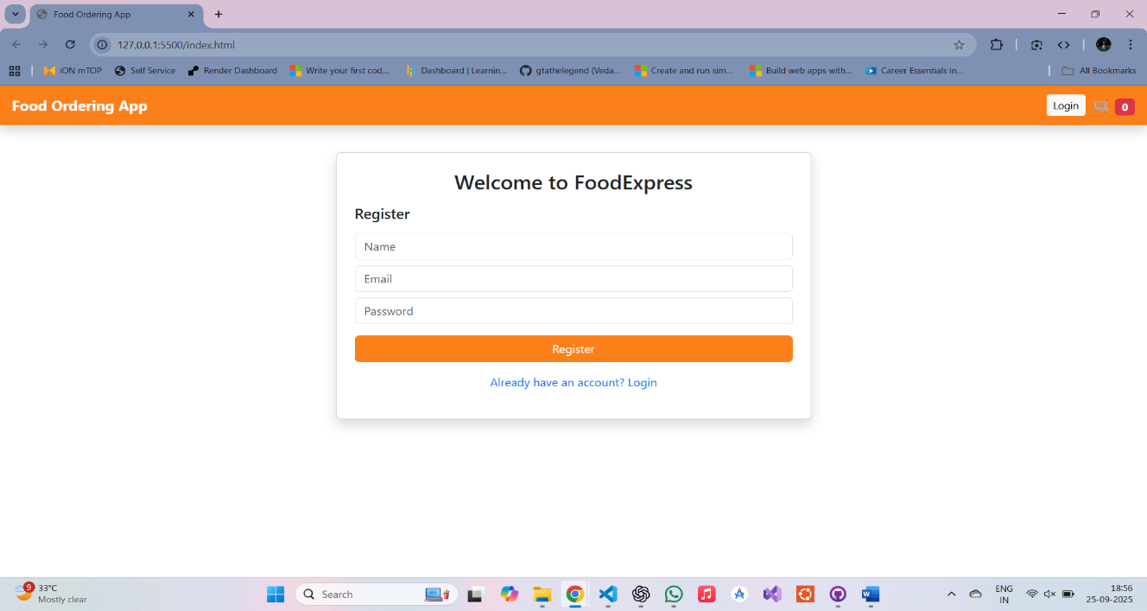
- Registration Page

- Registration Success
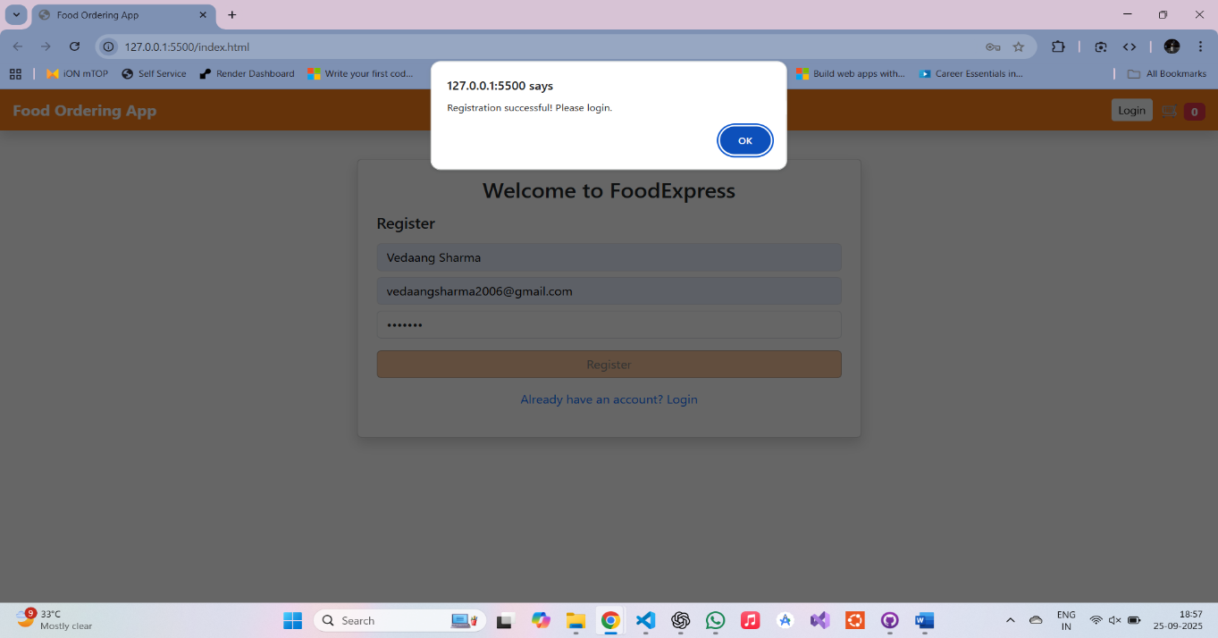
- Login Page
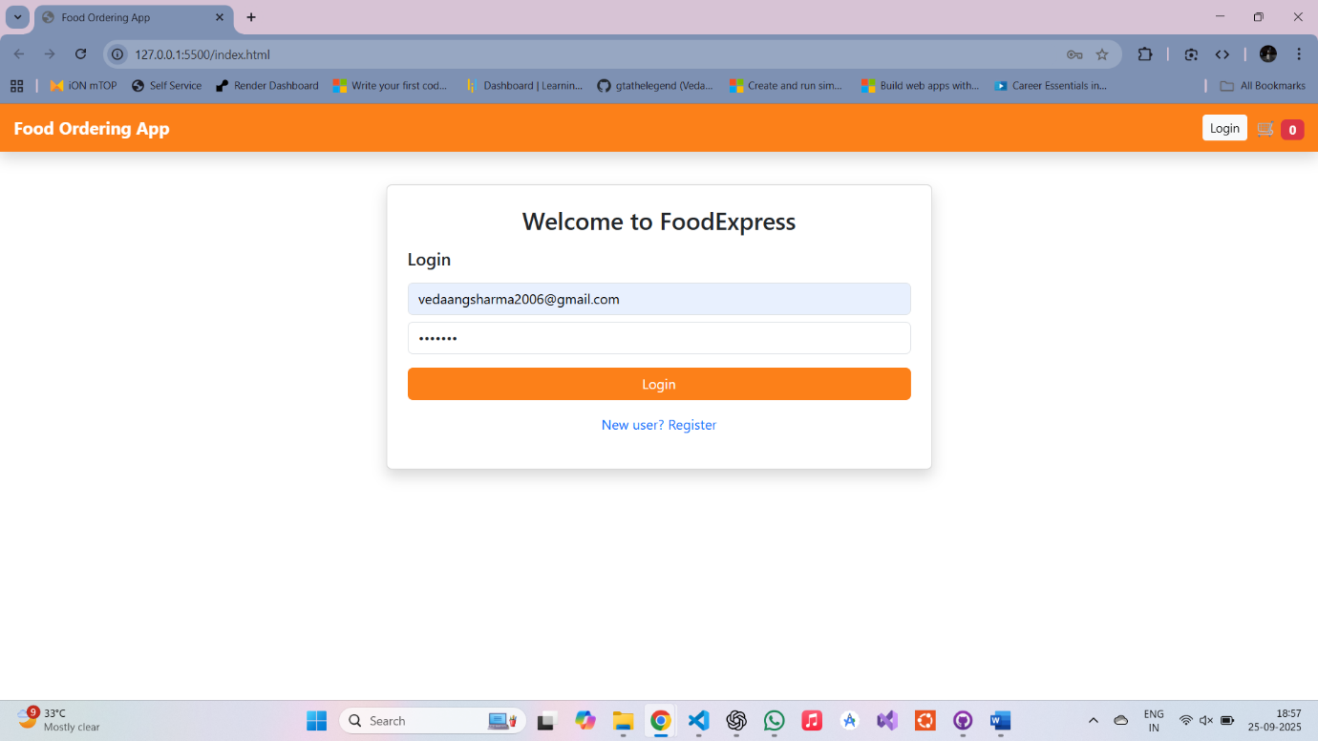

- Login Success

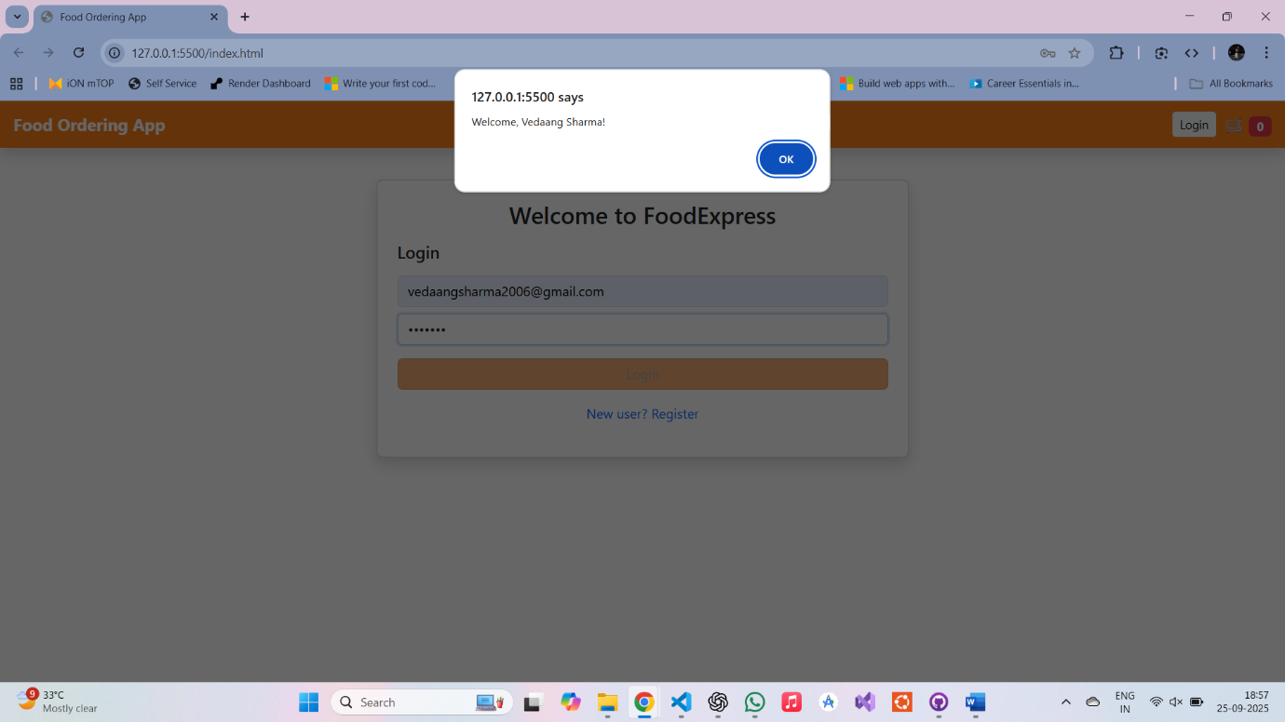

- Home Page
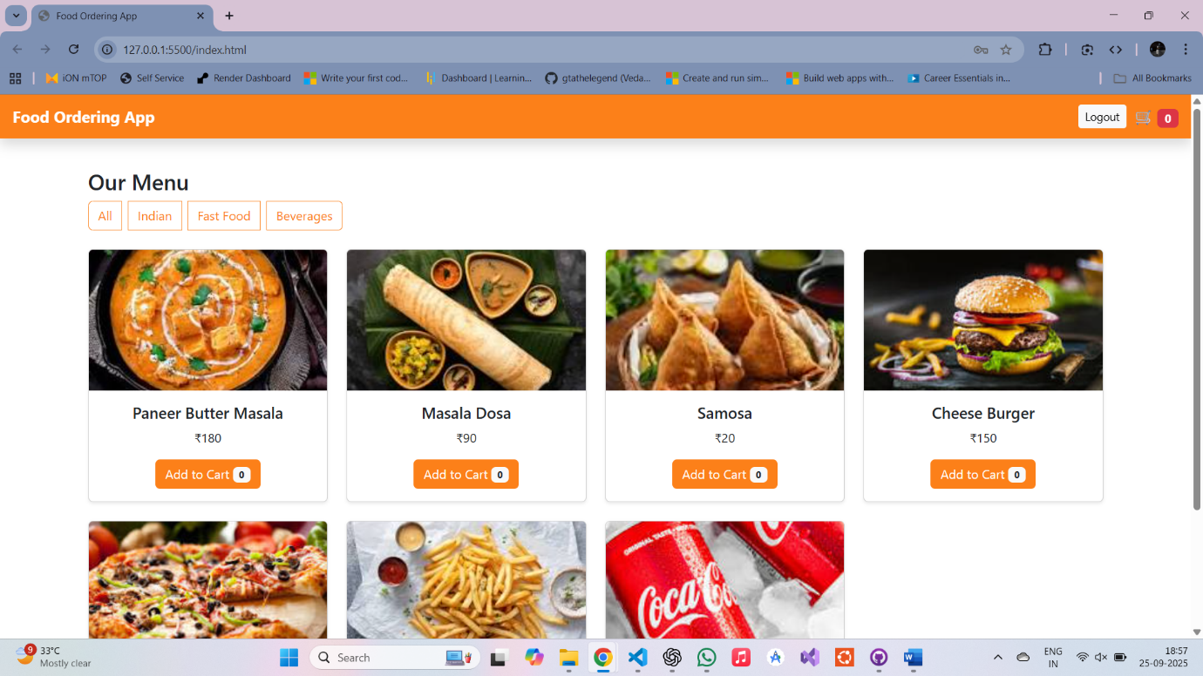

- Filtering Data : Indian Food

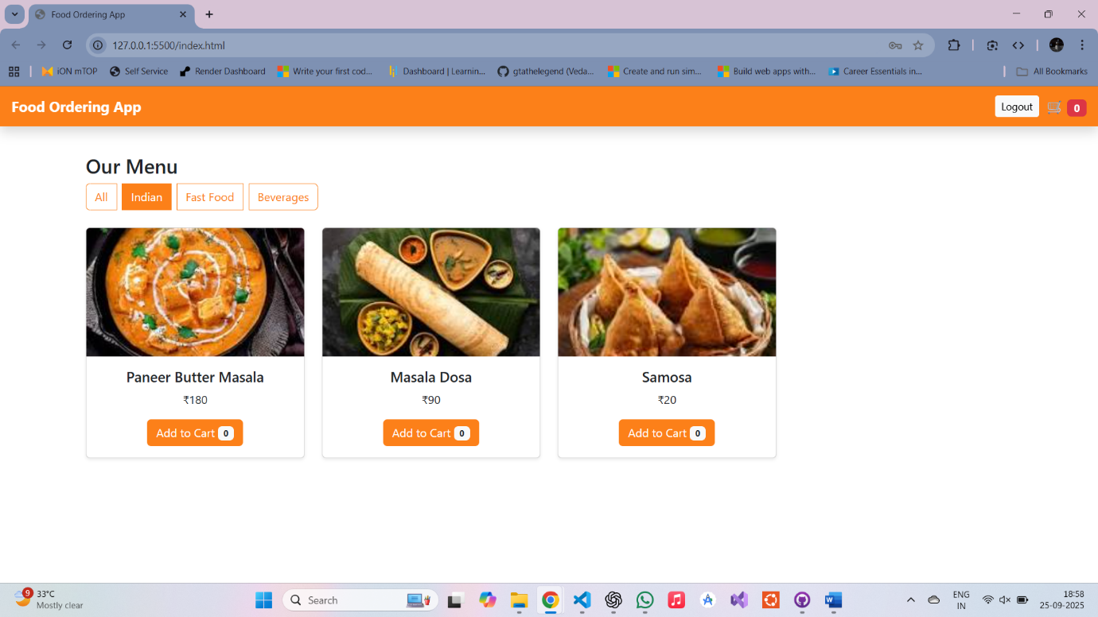

- Filtering Data : Fast Food
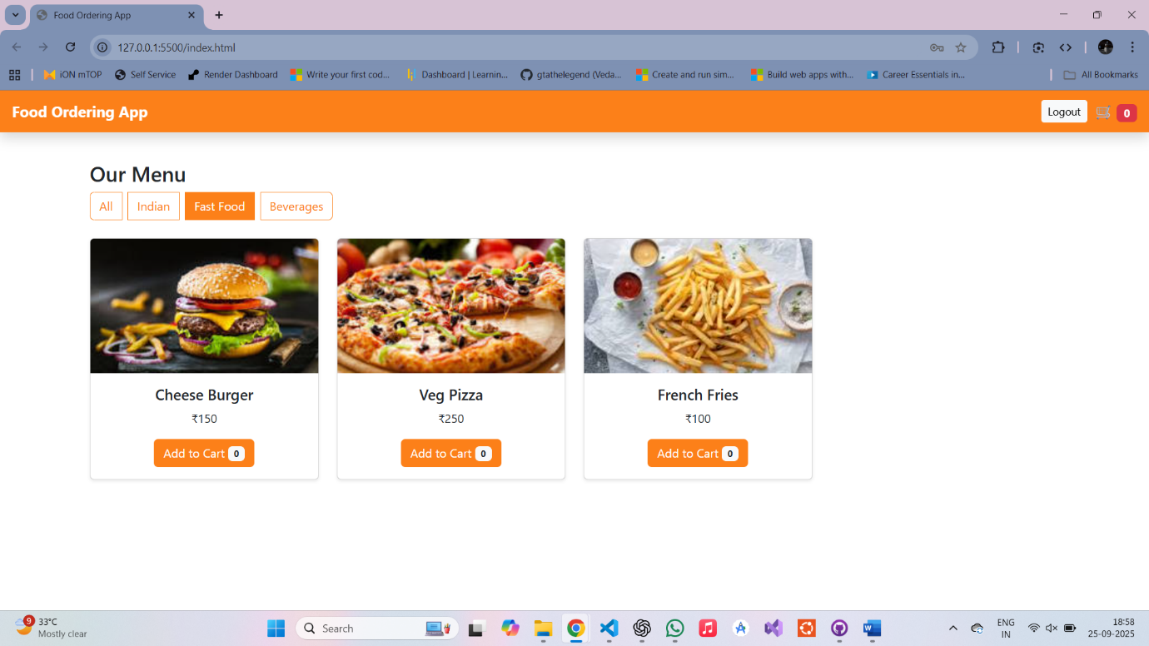

- Filtering Data : Beverages
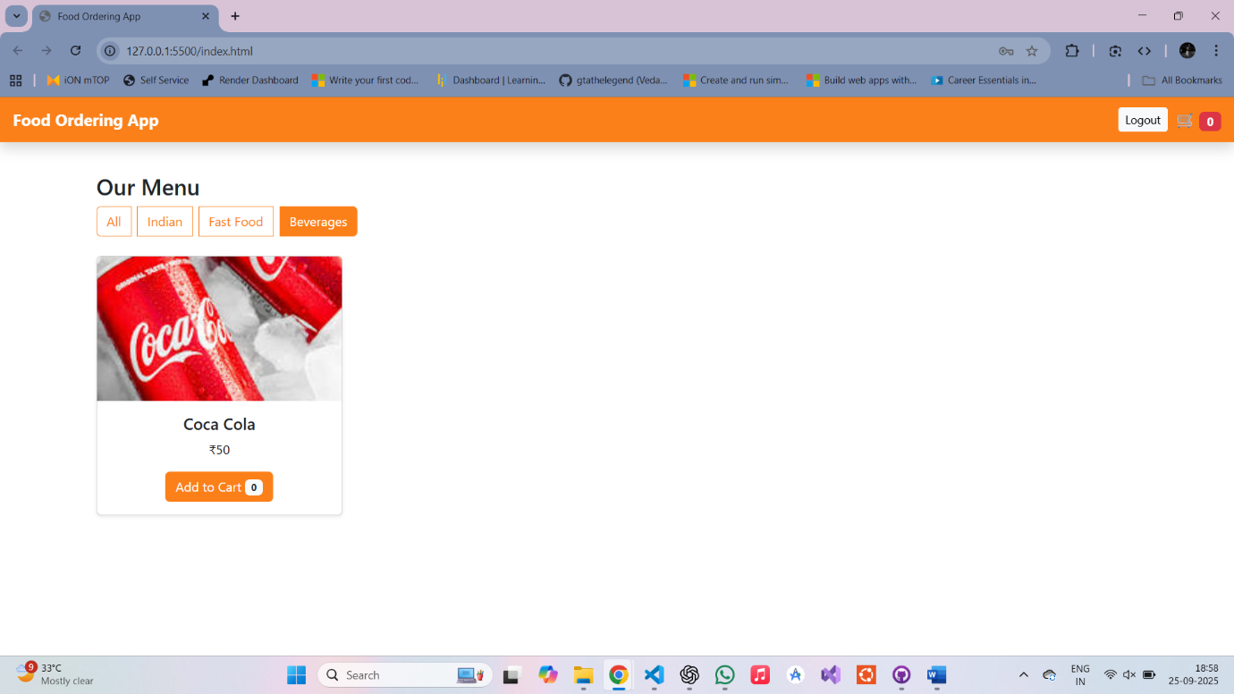

- Adding Food Items to Cart
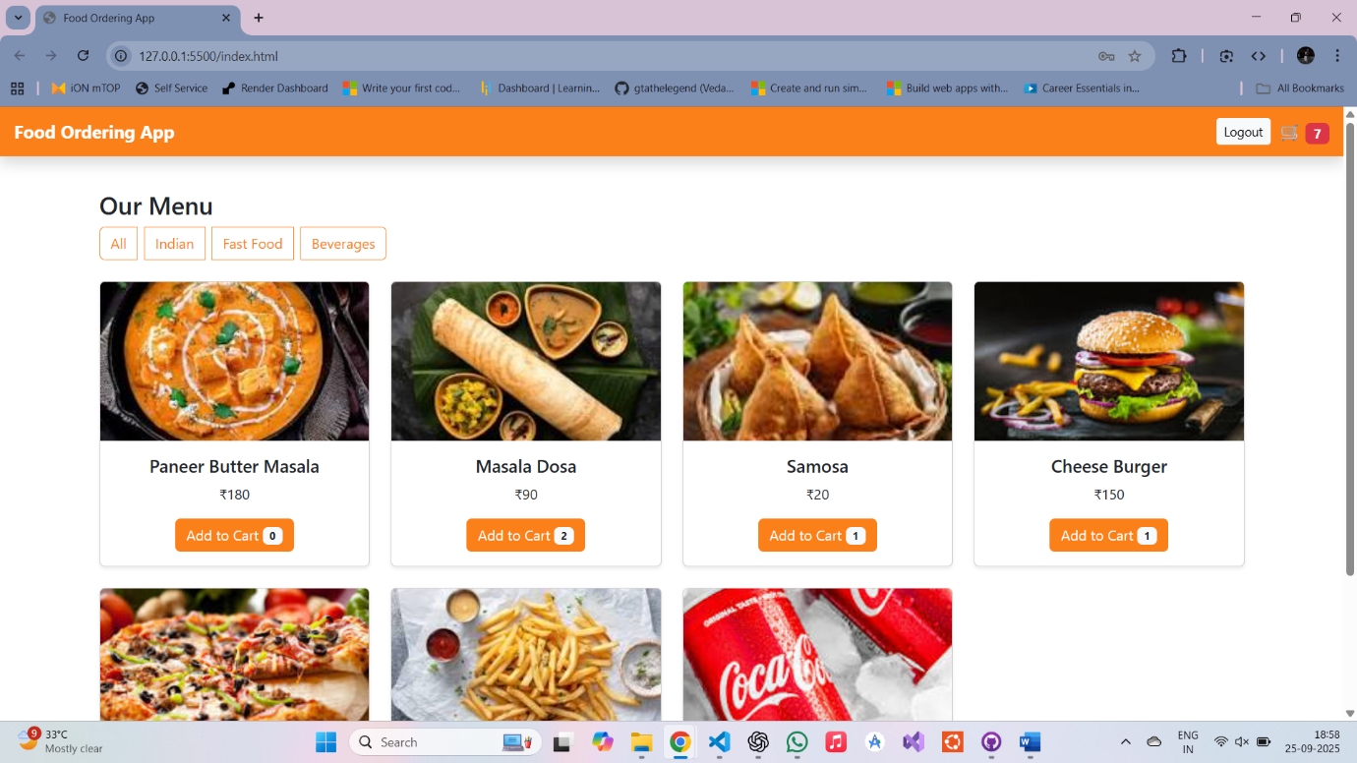

- Cart Page
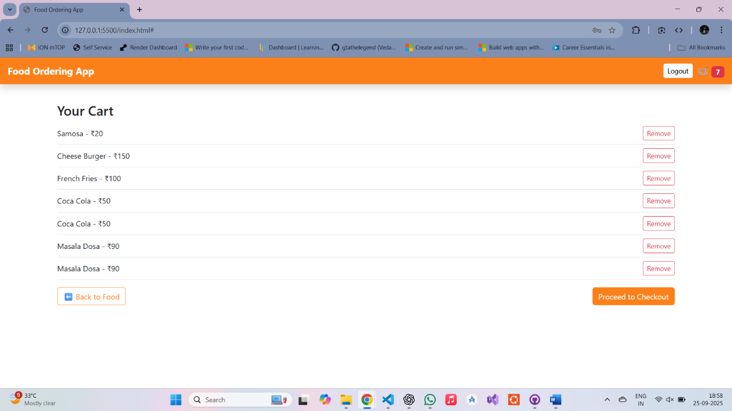

- Checkout Page : Address and Phone Number Input from User
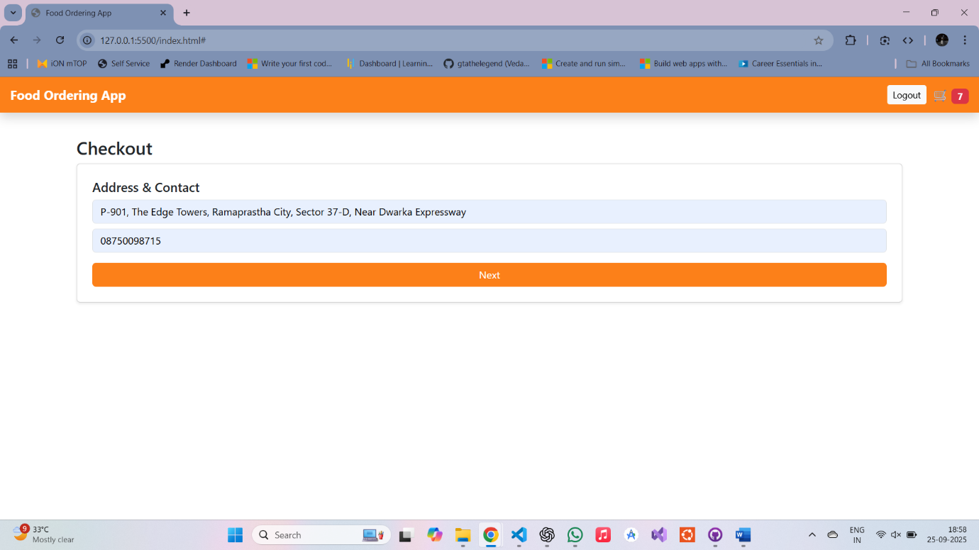

- Getting Payment Information ( Dummy Card Details )
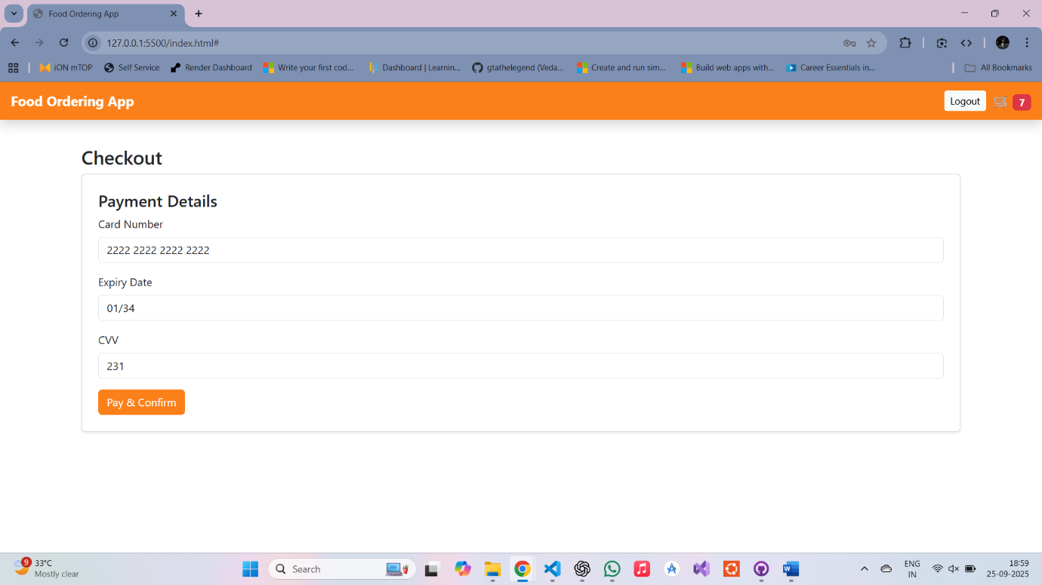

- Order Success Message
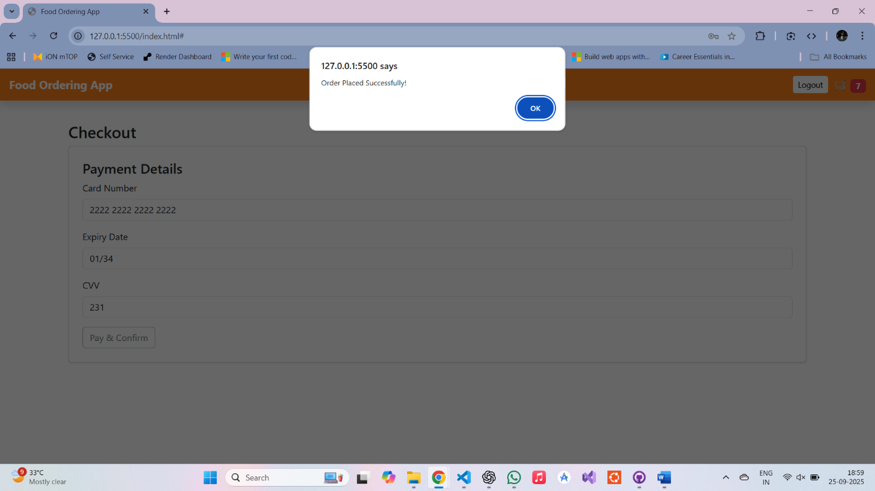

- Order Confirmation
